Oyster Bar Menu
Natural Oysters Single ½ Doz Doz

Naked $3 $11 $18
Freshly shucked and served with lemon
Dressed $14 $21
Naked oysters served with 3 dressings
on the side (see board inside)

Cooked Oysters (no takeaways available)
Get Shucked prides itself on freshness; our cooked items are prepared when
ordered and may take 10 minutes
½ Doz Doz

Oyster Wontons $15 $25
Wrapped in wonton pastry, deep fried and
served with wasabi cream.

Mother in Law’s Kilpatrick $15 $25
Cooked in the shell and topped with Marie T’s
worcestershire sauce and Bruny Island Foods bacon.

Asian Fusion $17 $28
Our take on mixing flavours from Asia,
A panko crumbed oyster sits on a nest of
rice noodle salad, topped with a tasty dressing.

Steamy Oriental Oysters $15 $26
Poached in its shell with a broth of white miso, ginger, lime,
chilli and other secret bits.

Get Shucked Platter $52
Just can’t decide, sample a variety of our oysters
in this platter. 3x wontons, 3x kilpatrick’s, 3x Asian Fusion,
6 natural, 6 smoked oysters, Bruny Sour Dough,
lemon and dressings.
Suitable for 2 to share.

Oyster Pate’ $14
Scrumptious flavours of Get Shucked oysters,
Bruny Island foods bacon, Tassie wine, garlic,
dill and more in this “to die for” homemade pate’.
Served with warm sour dough bread.

Warm Sour Dough Bread $5
Baked by our mates at the Bruny Island Cheese co,
served with butter.
or
Add dippy bits, tomato vinaigrette, wasabi cream $8

Hot chips $7
Yes they come with sauce!

Specials
See the board inside or ask our usually friendly staff.

Drinks (no takeaways available)
Oyster Shooters
Bloody Mary $10
Tomato juice, half nip of 666 Tasmanian vodka,
lemon juice and Tabasco all in a shot glass on top of
a fresh oyster. Guaranteed dance in your pants!!

Beers
James Boags Premium (Tas) $7.5
Cascade Pale Ale (Tas) $7.5
Cascade Stout (Tas) $7
Coopers Pale Ale $7.5
Cascade Draught (Tas) $7
Cascade Premium Light (Tas) $6.5
Guiness $8.5
Moo Brew Pilsner (Tas) $8.5
Moo Brew Dark Ale (Tas) $8.5
Seven Sheds ‘Black Inca’ 500ml (Tas) $16

Drinks (no takeaways available)
Cider
Pagan Cider (Tas)
- Apple(4.5%), pear(4.5%) $8
- Cherry (8%) $9

Wines Glass Bottle
Oyster Bay Sav Blanc (NZ) $7 $30
Stefano Lubiana sav blanc (Tas) $9.5 $42
Josef Chromy Pinot Gris (Tas) $8 $37
Spring Vale Chardonnay (Tas) $8.5 $40
Bruny Island Chardonnay (Tas) $8.5 $40
Devils Corner Pinot Grigio (Tas) $8 $37
Devils Corner Riesling (Tas) $8 $37
Coal Valley Vineyard Riesling (Tas) $9.5 $40
Ninth Island Pinot (Tas) small Bottle $22 $40

Drinks (no takeaways available)

Sparkling
Jansz Cuvee $8.50 $42
Fourty-Two Degrees South Sparkling $9 $45

Spirits
Gin and Tonic $9
Bloody Mary $9

Non Alcoholic
The Good Apple (Tas) $4.5
Sparkling Blackcurrant, Raspberry or Apple
Tas Chilli Beer Co (Tas) $5.5
Plain OR Chilli Ginger beer
Lime sparkling

Tonic water $4

Hartz Mineral water $4

Hartz Cola $4.5

Apple juice $4.5

Orange Juice $4.5

Can’t get enough of Get Shucked eh!
Take away menu
Please order at the bar or use our drive through.

Natural Oysters single ½ Doz Doz

Naked $2 $9.50 $16
Freshly Shucked
Live $1 $6 $10
You need to shuck these.

Smoked $10 $18
Smoked on site, in a jar of olive oil.

Marinated $9 $16
Cooked, marinated In a jar of vinegar, lemon juice + other bits.

Oyster Pate’ $9

Marie T’s Worcestershire sauce $11 bottle
For making the best kilpatricks.

Lemons ½ 50c $1
Shucking Knives $8

Get Shucked is locally owned and operated by Joe Bennett and his partner Nicole Adams. In 2004 the farm was purchased as a barely going concern and Get Shucked was created.
Get Shucked buy their oysters from other farms at about 40mm in size and use the pristine cool waters of the D'Entrecasteaux channel to finish them into fat, 60-80mm oysters. The oysters are suspended from long float lines in trays and filter nutrient out of the pure waters 24 hours per day. This process takes around 4 - 6 mths and produces a full, sweet flavoured pacific oyster.

Past to present.
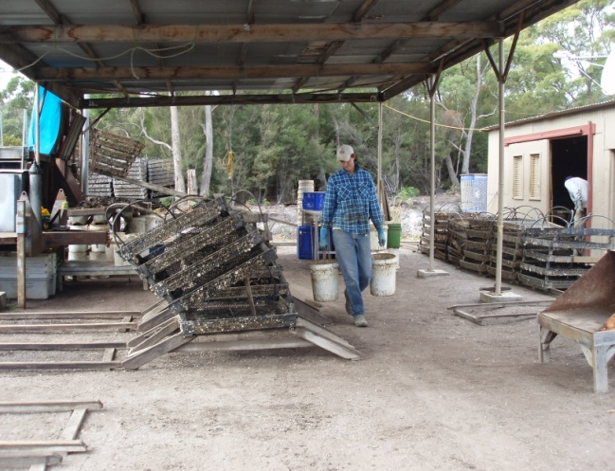
A long line system suspended with buoys holds the crates of oysters in approx 8m of water.
Early days saw staff working in an open sided shed with a dirt floor

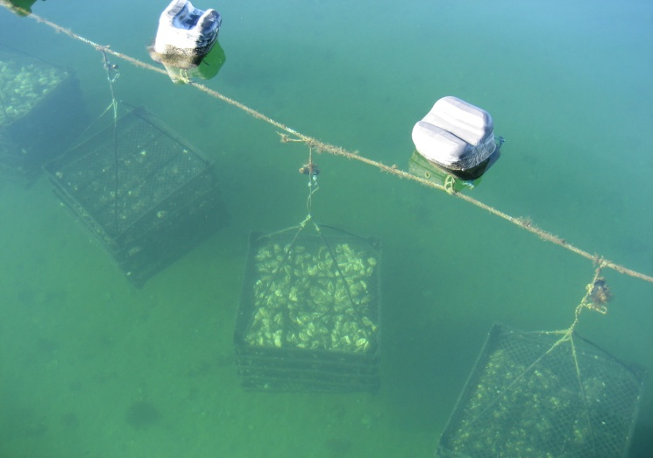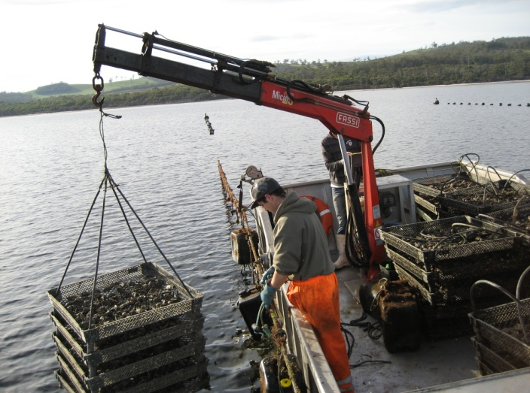
As the oysters are in deep water we use a boat (barge) equipped with a crane to access the oysters.

Customers enjoying the atmosphere of the old Fuel for love van (seen in the background)
Joe started shucking oysters for passing traffic in 2005 in a garden shed on pallets.
The operation was upgraded to the world famous food van in 2007. The Fuel for Love van housed the humble little shop for 6 years, demand outgrew the facility and both customers and staff needed better facilities (especially during winter).
On 14th of December 2013 the new processing facility and oyster bar was opened.
We hope you enjoy what we have created. No government funding has been used to build this business, just bloody hard work!

